A.V.KAVERI,
192512188.
Experiment No : 6
Title: Simulation of Threat Modeling & Security Hardening in IoE Smart Banking System Using Python (Google Colab)
Aim
To develop and simulate an IoE Smart Banking Security System using Python in Google Colab that generates ATM transactions, monitors for potential cyber threats, classifies transactions as safe or blocked, and visualizes security status through real-time tables and graphs.
Objective
The objective of this experiment is to simulate a smart banking environment where multiple ATM transactions are processed and analyzed for security threats. The system generates random transaction data including ATM ID, customer ID, and transaction amount. Each transaction is evaluated against possible threats such as ATM Spoofing, Brute Force, Data Tampering, and DoS Attack. Transactions are classified as either SUCCESS (safe) or BLOCKED (threat detected). The system displays transaction details in a live table and generates graphical visualizations for transaction amounts, success vs blocked status, and threat distribution. This experiment demonstrates how threat modeling and security hardening can be implemented through simulation using Python in Google Colab.
Software Requirements
- Google Colab
- Python 3.x
Python Libraries Used
- random
- hashlib
- pandas
- matplotlib
Theory
A Smart Banking Security System ensures safe financial transactions by continuously monitoring ATM activities. In real-world banking, IoE devices and secure protocols are used to detect and prevent cyber threats. Since physical banking infrastructure is not used in this experiment, transaction data and threats are simulated using randomly generated values.
The system processes multiple ATM transactions, encrypts user credentials using hashing, and evaluates each transaction against predefined threat categories. Safe transactions are marked as SUCCESS, while suspicious ones are BLOCKED. The results are displayed in tabular form and visualized through graphs, enabling clear observation of transaction patterns and threat distribution.
This simulation demonstrates the working principle of a real-time banking security system without requiring physical ATMs or networks.
Algorithm
- Start the program.
- Import required Python libraries.
- Define username and password.
- Encrypt password using SHA-256 hashing.
- Create a list of ATM IDs.
- For each ATM:
  - Generate random Customer ID and Transaction Amount.
  - Randomly assign a Threat type (SAFE, ATM Spoofing, Brute Force, Data Tampering, DoS Attack).
  - Classify transaction as SUCCESS or BLOCKED.
- Store transaction details in a DataFrame.
- Display transaction report table.
- Count and display security summary (Safe vs Threats).
- Plot graphs:
  - Transaction Amount per ATM
  - Success vs Blocked transactions
  - Threat distribution (pie chart)
  - Customer transaction amounts
- Display completion message.
- Stop the program.
Flowchart
Code
START
│
Import Required Libraries
│
User Authentication (Hashing)
│
Generate ATM Transactions
│
Customer ID, Amount, Threat Type
│
Compare with Threat Categories
│
┌───────────┴───────────┐
│ │
▼ ▼
SUCCESS BLOCKED
│ │
└───────────┬───────────┘
▼
Store Transaction Information
│
▼
Display Transaction Report Table
│
▼
Generate Security Summary
│
▼
Plot Graphical Visualizations
│
▼
More Transactions Remaining?
│ │
Yes No
│ │
▼ ▼
Generate Next Display Final
Transaction Security Report
│
└──────────────►
▼
END
Threat Categories Used
Threat Type | Status Assigned
SAFE | SUCCESS
ATM Spoofing | BLOCKED
Brute Force | BLOCKED
Data Tampering | BLOCKED
DoS Attack | BLOCKED
Program Description
The Python program simulates ATM transactions across multiple ATMs. Each transaction includes customer details, transaction amount, and a randomly assigned threat type. Transactions are classified as SUCCESS or BLOCKED based on threat detection. Results are displayed in a DataFrame and visualized through bar charts, pie charts, and line graphs. The system provides a clear summary of safe vs attacked transactions, demonstrating how threat modeling and security hardening can be applied in smart banking.
Input
- ATM IDs
- Customer IDs
- Transaction Amounts
- Threat Types
Output
- ATM Transaction Report Table
- Security Summary Report
- Graphs:
  - Transaction Amount per ATM
  - Success vs Blocked Transactions
  - Threat Distribution
  - Customer Transaction Amounts
Observations
- Transactions are classified as SUCCESS or BLOCKED.
- Threat distribution is clearly visualized in a pie chart.
- Safe vs blocked transactions are compared in bar charts.
- Customer transaction amounts are plotted for analysis.
Applications
- Smart Banking Systems
- ATM Security Monitoring
- Cybersecurity Training
- IoE-based Financial Systems
- Threat Modeling Research
Advantages
- Real-time transaction monitoring
- Automatic threat detection
- Graphical visualization of security status
- Easy to understand and implement
- Cost-effective simulation without real ATMs
Limitations
- Uses simulated transaction data
- No real ATM hardware or network involved
- Does not notify banking staff in real time
- Suitable only for academic demonstration
Result
The IoE Smart Banking Security System was successfully simulated using Python in Google Colab. The system generated ATM transactions, detected threats, classified transactions as SUCCESS or BLOCKED, and displayed results through tables and graphs. Thus, the experiment demonstrated effective threat modeling, security hardening, and visualization in a simulated smart banking environment.

OUTPUT:
============================================================
IoE SMART BANKING SECURITY SYSTEM
============================================================

Login Successful
Username : admin
Password Hash : cf7f4acfb75a04e498be ...

ATM Transaction Report

ATM ID Customer ID Amount Threat Status
0 ATM001 1012 9423 Brute Force BLOCKED
1 ATM002 1042 9334 DoS Attack BLOCKED
2 ATM003 1044 8706 ATM Spoofing BLOCKED
3 ATM004 1002 5036 DoS Attack BLOCKED
4 ATM005 1040 2171 SAFE SUCCESS

========== SECURITY REPORT ==========
Safe Transactions : 1
ATM Spoofing : 1
Brute Force : 1
Data Tampering : 0
DoS Attack : 2
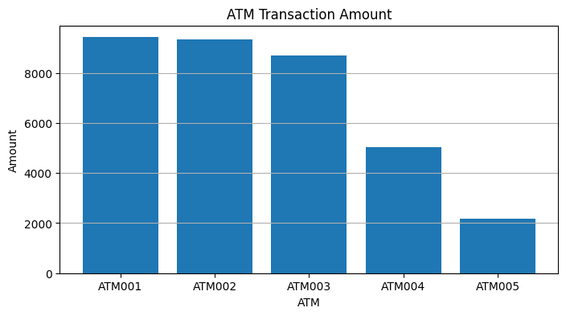
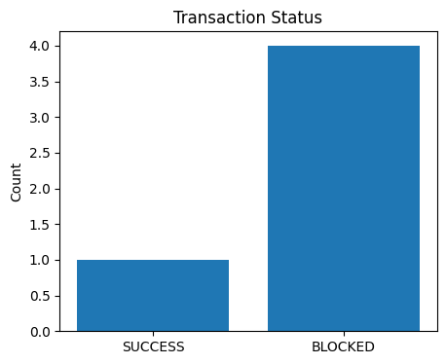
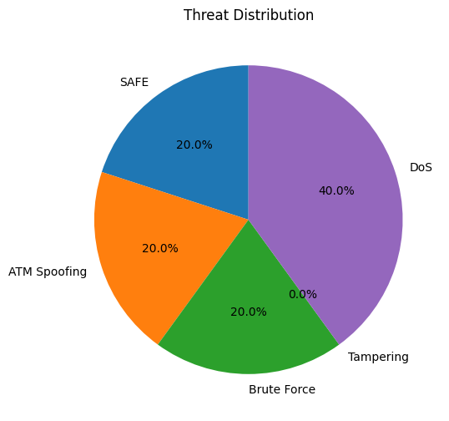
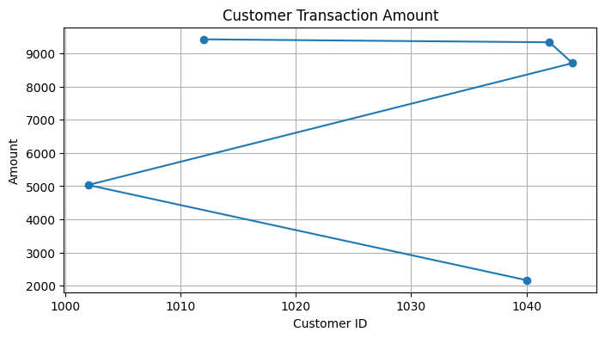
======================================
Threat Modeling Completed Successfully
Security Hardening Applied
System Protected Successfully
======================================

